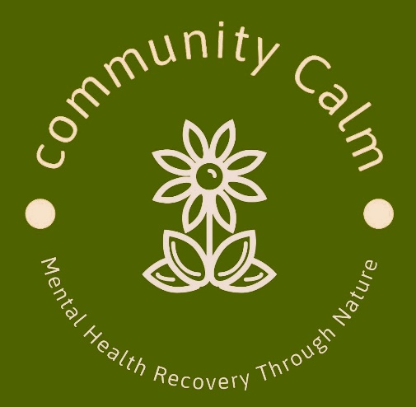

Compliments, Complaints & Comments Policy & Procedure
Community Calm CIC
Mandeep Kalsi. Director/Founder
Company No. 15595187
Date : Feb 2026
Review : Feb 2027

Statement
Community Calm CIC aims to provide all its users with the best possible service at all times. It is important to us that people are able to express their feelings and experiences of the services we provide. These can be both good and bad. If we know what your experience is, we can build on what we are doing well and introduce changes where they are needed. If you are unhappy with your experience we also need to know. This will help us improve our services for all who use them. You might want to complain, give us a compliment or make some comments about the service you have experienced.
A compliment involves you telling us about a service you received that you are particularly pleased with.
We can then pass on your appreciation to our staff. We are always delighted when you take the time to contact us about a good experience you have had at Community Calm CIC.
A complaint involves you telling us when you are unhappy with a service you received or the way you feel you were treated by Community Calm CIC.
We are keen to ensure that everyone who has contact with us has a positive experience. Sometimes a complaint can be the catalyst for change. When a complaint is upheld we will review our service ensuring that where possible and appropriate we involve the complainant in the review process.
A comment involves you giving us your point of view about the services we provide.
Your information can help us consider how we deliver our services and may help us make changes that will benefit everyone.
Who can complain?
Anyone who receives a service or enquires about a service can use this procedure. Alternatively, you may prefer to have someone complain on your behalf. This could be a friend, employer, or support worker who can speak on your behalf.

What can I complain about?
• We have failed to give you access to information or have given you incorrect advice or information.
• We have not treated you politely.
• We have discriminated against you or not treated you fairly.
• We have not responded to you within appropriate timescales.

What you cannot complain about
You may be disappointed with the advice or information given, but you cannot use the complaints procedure to complain about information and advice if it is correct and appropriate at the time it was given.

MAKING A COMPLIMENT, COMPLAINT OR COMMENT
How to make a comment or compliment
We welcome comments, compliments and suggestions as these can help us improve our services. Please send any comments to
Meena Kalsi
Email ; communitycalmberkshire@gmail.com
Phone 07917 207510
Or
Asma Aziz @ Slough CVS
Email : asma@sloughcvs.org.uk
Phone 07813 643648
We hope that you will always be satisfied with our service and look forward to receiving your comments. If we get it right or wrong we would like to know.
How to make a complaint:
If you are not happy with the service you have received, please contact
Meena Kalsi
Email ; communitycalmberkshire@gmail.com
Phone 07917 207510
of
Asma Aziz @ Slough CVS
Email : asma@sloughcvs.org.uk
Phone 07813 643648

Please state:
• What happened
• When it happened
• Who dealt with you
• What you would like us to do to put things right.
The person responsible for the service you have received will try to put things right in the first instance, and we would hope to settle complaints as quickly as possible in this way. Please let us know at the time if there is anything we need to know about how to contact you (for example, if you would like us to reply by text phone or on audio tape).
Within 5 working days of receiving your complaint we will phone or write to you to say that we have received it. We will also tell you how to contact the person who is dealing with your complaint and when you can expect a reply.
If you cannot make your complaint in writing, please contact us via telephone on 07917 207510
Please let us know at the time of making your complaint if there is anything we need to know about how to contact you (for example, if you would like us to reply by text phone or on audio tape).
We will undertake to investigate the circumstances leading to the complaint and take steps to put the matter right. You will receive a reply to your complaint within 10 working days. If they cannot give you a full response at this time, they will tell you why and when you are likely to receive it.
Records of complaints, including details of our investigation and our findings, will be kept on file for at least 6 years.

