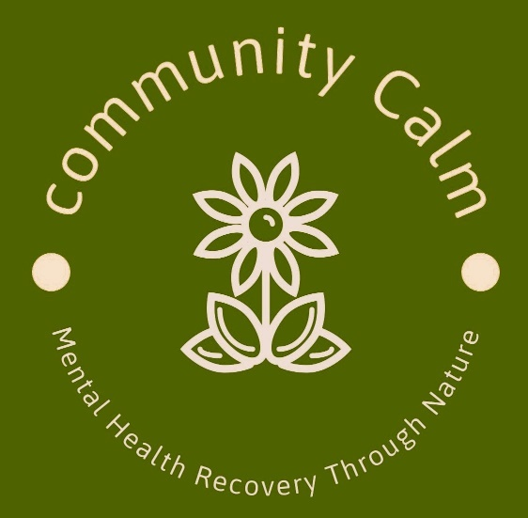
Health and Safety Policy
Community Calm CIC
Mandeep Kalsi. Director/Founder
Company No. 15595187
Date : Feb 2026
Review : Feb 2027

- Community Calm CIC) recognises and accepts its responsibilities to ensure its Health and Safety Policy is adhered to and implemented.
- It recognises its duties under the Health and Safety at Work Act, the Environment Protection Act and the Fire Precaution Act to ensure: The health, safety and welfare of all its staff, volunteers and visitors whilst working for visiting the organisation.
- All activities carried out by Community Calm CIC are done in accordance with the Health and Safety Policy.
- An appropriate health and safety policy that is regularly reviewed is in place. In particular Community Calm CIC will ensure:
- Community Calm CIC provides a safe place to work and a healthy working environment.
- The health, safety and welfare of all its staff, volunteers, users of its services and any visitors to its activities or premises.
- That all activities take place in a safe place where appropriate risk management procedures have been carried out.
- That any equipment is fit for purpose, used safely, by appropriate personnel and in accordance with instructions.
- That any activities are undertaken in such a way so that all those involved contribute positively to their own health and safety.
- Our activities take part on a working farm which includes exposure to farmyard animals. Remember to always be calm around them and do not make sudden and loud noises which could frighten them.
- Always wear appropriate for a farm – the surface could be uneven, wet and/or muddy. Closed shoes or wellies should always be worn to avoid risk of injury.
- Community Calm CIC will not be held responsible for your visit/transport to and from the activities on Heroes Farm.
- That training on health and safety will be given in proportion to the responsibility being exercised.
- That appropriate insurance policies are in place and reviewed regularly.
- That particular attention will be paid to fire precautions, emergency procedures and physical security.
- That food and drink are served in accordance with environmental regulations.
- That first aid requirements are considered by the group and that there are appropriately trained staff and volunteers.
- That staff, volunteers and visitors take reasonable care for their own health and safety and the health and safety of those who may be affected by their actions.
- That staff report any hazards, defective equipment, ineffective procedures and policy to their immediate supervisor and only undertake tasks for which they are appropriately trained.

