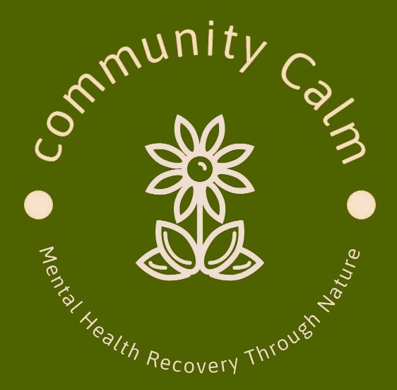

**Health and Safety Policy**

**Community Calm CIC**

**Mandeep Kalsi. Director/Founder**

**Company No. 15595187**

**Date : April 2024**

**Review : April 2025**

1. Community Calm CIC) recognises and accepts its responsibilities to ensure its Health and Safety Policy is adhered to and implemented.
2. It recognises its duties under the Health and Safety at Work Act, the Environment Protection Act and the Fire Precaution Act to ensure: The health, safety and welfare of all its staff, volunteers and visitors whilst working for visiting the organisation.
3. All activities carried out by Community Calm CIC are done in accordance with the Health and Safety Policy.
4. An appropriate health and safety policy that is regularly reviewed is in place. In particular Community Calm CIC will ensure:
5. Community Calm CIC provides a safe place to work and a healthy working environment.
6. The health, safety and welfare of all its staff, volunteers, users of its services and any visitors to its activities or premises.
7. That all activities take place in a safe place where appropriate risk management procedures have been carried out.
8. That any equipment is fit for purpose, used safely, by appropriate personnel and in accordance with instructions.
9. That any activities are undertaken in such a way so that all those involved contribute positively to their own health and safety.
10. Our activities take part on a working farm which includes exposure to farmyard animals. Remember to always be calm around them and do not make sudden and loud noises which could frighten them.
11. Always wear appropriate for a farm – the surface could be uneven, wet and/or muddy. Closed shoes or wellies should always be worn to avoid risk of injury.
12. Community Calm CIC will not be held responsible for your visit/transport to and from the activities on Heroes Farm.
13. That training on health and safety will be given in proportion to the responsibility being exercised.
14. That appropriate insurance policies are in place and reviewed regularly.
15. That particular attention will be paid to fire precautions, emergency procedures and physical security.
16. That food and drink are served in accordance with environmental regulations.
17. That first aid requirements are considered by the group and that there are appropriately trained staff and volunteers.
18. That staff, volunteers and visitors take reasonable care for their own health and safety and the health and safety of those who may be affected by their actions.
19. That staff report any hazards, defective equipment, ineffective procedures and policy to their immediate supervisor and only undertake tasks for which they are appropriately trained.