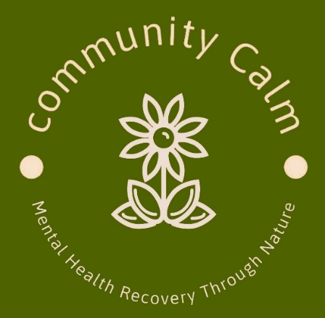
Community Calm CIC
“Mental Health Recovery Through Nature”
Referral Form
Name

Address

DOB

Telephone Number

Email

Next of Kin
Name and Contact Info Where Possible
Doctor’s Surgery

Other Healthcare Professional

Referred By

Mental Health Diagnosis
(Current and/or Historic)

Are You Happy To Share Your Mental Health Struggles In Our Closed Setting?
(This is so we know how to support you within the group)

Any other Mental or Physical Healthcare Needs

What Would You Like To Achieve From Being Part Of Community Calm?

Are You Able To Bring Yourself Independently To Our Group?

Signed

Date

Community Calm CIC is a free service to provide social support and connection through nature based activities for those experiencing isolation, loneliness and mild mental health care needs. We offer a non-judgemental and inclusive setting for people to feel safe and find purpose amongst those who may be going through similar feelings and emotions.
We do not offer clinical therapy or advice.
Each referral is taken on a case by case basis so we can ensure each person is supported correctly. If we feel that we are unable to support you then we may be able to signpost you elsewhere.
Feel free to contact us with any questions ;

Meena Kalsi
Director/Founder
Community Calm
07917 207510
communitycalmberkshire@gmail.com

Privacy

We care about your privacy and want you to know that your information is held confidentially and not shared with anyone else.
Do you agree to let us hold on to the information you shared on this form? YES NO (Please circle)

Signed

Date

Photos :
Are you happy for your photo to be used in promotional material?
We do not identify faces and only take pictures while engaged in an activity. Pictures are used as evidence for funders

Yes No (Please circle)

Community Calm – Criteria Information

1. Who We Support
Adults (18+) who would benefit from:
- Gentle, non-clinical, nature-based recovery/being outdoors
- Reduced isolation, improved routine, and grounding
- Small, quiet, and confidential group settings
- Low-demand creative, sensory, or nature-based activities
- Support following stabilisation from crisis or alongside ongoing clinical care

Suitable for individuals experiencing:
- Anxiety, low mood, or emotional overwhelm
- Social withdrawal or loneliness
- Post-crisis vulnerability
- Difficulty engaging in busy or clinical environments

2. Referral Routes
Referrals are accepted from:
- CMHT teams
- Talking Therapies services
- Crisis Teams (post-crisis step-down)
- GPs
- Social Prescribing teams
- Other NHS or community health professionals
Please note: Self-referrals are not accepted.

3. Inclusion Criteria
Participants should be able to:
- Attend sessions without 1:1 clinical supervision
- Engage safely within a mixed community group
- Respect confidentiality and group boundaries
- Participate at their own pace (quiet presence is welcomed)
Support workers or carers may attend initial sessions where appropriate.

4. Exclusion Criteria
This service may not be suitable for individuals who:
- Are in acute crisis or require urgent clinical intervention
- Present with high-risk behaviours that cannot be safely supported in a group setting
- Require intensive 1:1 support or continuous supervision
- Need specialist clinical treatment during sessions
- Are currently unable to safely participate in a mixed community environment

5. Accessibility & Support
- Mobility and sensory needs can be accommodated with prior notice
- All sessions are closed, confidential, and non-clinical
- No photography or social media use permitted
- Nature-based sessions may include outdoor environments, gentle walking, and creative activities, animals, gardening and other eco therapy activities

