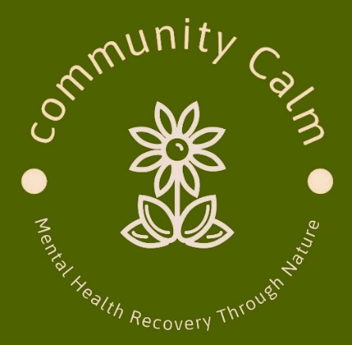
Helpful Concepts
Community Calm CIC
Mandeep Kalsi. Director/Founder
Company No. 15595187

Community Calm: Principles & Guidelines
At Community Calm, we are committed to providing a safe, respectful, and inclusive environment. Please take a moment to familiarise yourself with our guiding principles. If you have any questions, a member of staff will be happy to assist you.

Our Community Values
- This is a free service for adults aged 18+ living within RBWM and surrounding counties.
- We take a person-centred approach and intentionally remain a small service so we can give each individual the focused support they need.
- Community Calm exists to provide a supportive space where individuals can share experiences, find strength, and encourage one another.
- We promote an atmosphere of acceptance and mutual respect. Everyone is welcome, regardless of background or past experiences.
- We do not judge, criticise, or argue. We listen with empathy and respect. Domineering or disruptive behaviour will be challenged.
- This is not a forum for giving advice. Our focus is on detaching from unhelpful emotions and fostering inner calm.
- Sessions are not intended to be used as a place to repeatedly revisit the same problems, as this may unintentionally affect your own and others’ wellbeing.
- Confidentiality is essential. What is shared within the group remains within the group unless a safeguarding concern arises.
- All opinions are to be respected. While views may differ, each perspective is valid.
- To maintain a neutral and supportive environment, discussions on religion, politics, or global affairs are not permitted.
- Please consider carefully before sharing sensitive or deeply personal information.
- Community Calm CIC is not responsible for any personal relationships formed outside the group.
- If you are concerned about another group member’s wellbeing, please inform a member of staff.

Attendance Expectation
- Members are expected to attend at least two sessions per month, at any of our locations. Regular attendance supports your own recovery journey and strengthens the collective wellbeing of the group.
Gifts to Volunteers
- Please do not offer or give gifts to any of our volunteers. While they deeply appreciate the gesture, their support is freely and happily given.

Farm & Safety Guidelines
- Some of our activities take place on working farms where animals are present. Please remain calm and avoid sudden or loud noises that may startle them.
- Community Calm CIC is not responsible for travel to and from any location.
- Being around animals carries potential health risks. Please wash your hands regularly, especially after handling them.
- Appropriate clothing must be worn. Conditions may be uneven, wet, or muddy, so closed-toe shoes or wellington boots are required.
- Discrimination of any kind—based on race, religion, gender, sexual orientation, or disability—will not be tolerated.
- Anyone under the influence of alcohol or illegal substances will not be permitted to attend.
- All participants must follow our Health and Safety guidelines.

A Reflection for Consideration
“Grant me the serenity to accept the things I cannot change,
courage to change the things I can,
and the wisdom to know the difference.”
— Emotions Anonymous



Please date and sign below that you understand and agree to these concepts :

Name :
Date:
Signed:

