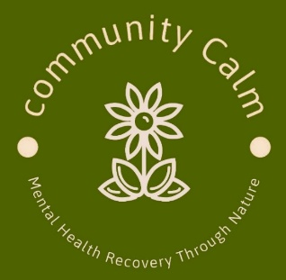

**Who We Are**

**🌿 Community Calm**

**Nature • Connection • Kindness**

**Who We Are**

Community Calm is a not-for-profit, grassroots initiative that provides a welcoming space for adults (18+) who may be feeling lonely, anxious, or low. We offer gentle, nature-based activities in small, supportive groups designed to improve wellbeing and connection.

**Where We Meet**

* **Hero’s Berkshire, Holyport (RBWM):** A small, peaceful animal therapy farm.
* **The Wildlife Trust/Crown Estate, Windsor Great Park:** A restorative natural setting for monthly gatherings.
* **Herschel Park, Slough:** A beautiful historic park and garden space, offering easy access to nature in the heart of Slough.

**What We Offer**

Regular sessions include:

* Relaxed tea/coffee and conversation
* Arts and crafts, board games
* Animal care and handling (Hero’s farm)
* Light gardening and gentle outdoor activities
* Guided relaxation and chair yoga
* Quiet time in nature

**Why It Matters**

Spending time outdoors and connecting with others is proven to reduce stress, ease loneliness, and support recovery. Many of our members say Community Calm helps them feel:  
✔ More positive and motivated  
✔ Less isolated and alone  
✔ Part of a friendly community

**Our Approach**

We are **non-clinical and peer-supported**. Sessions are guided by kindness, inclusivity, and mutual respect. We focus on principles over personalities — creating a safe, non-judgemental space where everyone feels valued.

**Referral Process**

🔹 **For patients:**  
Community Calm does not accept self-referrals. If you would like to attend, please take this information to your GP, Social Prescriber, or another healthcare professional. They can complete the referral form on your behalf and send it directly to us.

🔹 **For health professionals:**  
Referrals can be made by GPs, Social Prescribers, NHS staff, or community health teams. Please complete the referral form and email it to:  
📧 **communitycalmberkshire@gmail.com**

**How It Works**

* **Weekly sessions:**  
  • **Monday** — Hero’s Berkshire (Holyport)  
  • **Tuesday** — Herschel Park (Slough)
* **Monthly nature gatherings:** In the private grounds of Windsor Great Park
* **Peer support & reflection:** Optional group discussion at the end of each session
* **Confidential & safe:** No medical advice given — sessions are non-clinical and complementary

**Contact**

📞 **Meena Kalsi** — 07917 207510  
📧 [**communitycalmberkshire@gmail.com**](mailto:communitycalmberkshire@gmail.com)

We look forward to seeing you.