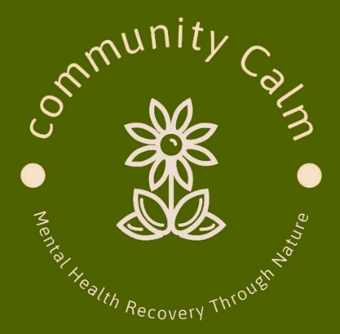

**Helpful Concepts**

**Community Calm CIC**

**Mandeep Kalsi. Director/Founder**

**Company No. 15595187**

***Community Calm: Principles & Guidelines***

*At Community Calm, we are committed to providing a safe, respectful, and inclusive environment. Please take a moment to familiarise yourself with our guiding principles. If you have any questions, a member of staff will be happy to assist you.*

**Our Community Values**

* This is a free service for adults 18 years + living within RBWM and surrounding counties.
* We take a person centred approach and are a small service by choice so we can direct and focus our attention in a measured way. This is to ensure that adequate support is given to each person coming to us
* Community Calm exists to provide a supportive space where individuals can share experiences, find strength, and offer encouragement to one another.
* We promote an atmosphere of acceptance and respect. Everyone is welcome, regardless of their background or past experiences.
* We do not judge, criticise, or argue. Instead, we listen with empathy and mutual respect. Domineering behaviour will be challenged.
* This is not a forum for giving advice. Our focus is on detaching from unhelpful emotions and cultivating a sense of inner peace.
* Sessions are not meant to be used as a soundboard for repeatedly revisiting our problems, which can unintentionally impact our own and others’ wellbeing.
* Confidentiality is of the utmost importance. What is shared within the group remains within the group, unless a safeguarding concern arises.
* All opinions are to be respected. While views may differ, each perspective is valid.
* To maintain a neutral and supportive environment, discussions on religion, politics, and global affairs are not permitted.
* Please consider carefully before sharing sensitive or personal information.
* Community Calm CIC is not responsible for any personal relationships formed outside the group.
* If you are concerned about the wellbeing of another group member, please inform a member of staff.

**Farm & Safety Guidelines**

* Our activities take place on a working farm where animals are present. Please remain calm and avoid sudden or loud noises that may startle them.
* Community Calm CIC is not responsible for travel to and from Heroes Farm or The Wildlife Trust/Crown Estate.
* Being around animals carries potential health risks. Please wash your hands regularly, particularly after handling them.
* Appropriate clothing must be worn. As farm conditions may be uneven, wet, or muddy, closed-toe shoes or wellington boots are required.
* Discrimination of any kind—whether based on race, religion, gender, sexual orientation, or disability—will not be tolerated.
* Anyone under the influence of alcohol or illegal substances will not be permitted to attend.
* All participants must adhere to our Health and Safety guidelines.

***A Reflection for Consideration***

*"Grant me the serenity to accept the things I cannot change,  
courage to change the things I can,  
and the wisdom to know the difference."*

*— Emotions Anonymous*



**Please date and sign below that you understand and agree to these concepts :**

**Name :**

**Date:**

**Signed:**